

13th May 2026

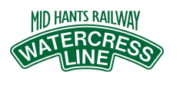
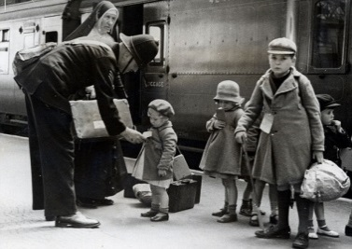
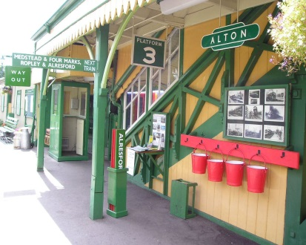

Dear Parents,
We are delighted to inform you about an upcoming educational visit for children in Years 3 & 4. To further develop the children’s understanding of what life was like as a child in Britain during World War 2, we will be taking the children on a WW2 – evacuee themed – steam railway journey on the Watercress Railway Line, Alresford.
Due to the numbers that the train can accommodate, each class will go on separate days:
Hambledon Base: Wednesday 3rd June 2026
Droxford Base: Wednesday 10th June 2026
Meonstoke Base: Thursday 25th June 2026

This trip will give real, first-hand experience as to how the evacuees travelled to their new homes and villages during the war. This exciting trip will form part of our WW2 (Home Front) / D-Day topic and will be an invaluable experience in terms of motivating, memorable learning. Children will be asked to dress as evacuees for the day and find out what it might have been like to be evacuated.
We will arrive at Ropley station where children will wait on the platform until it’s time to board the steam train. We will then travel to Alton station. Here, children will experience what it was like to be ‘billeted’. After, they will visit the education centre and take part in some workshops. After a picnic lunch, we will then make a return trip on the train Ropley where we will make our way back to school via coach in time for the end of the school day. We feel this exciting day will be a fantastic opportunity for children to understand life during World War II and we will support their learning at school.
To complement this visit, we will also be taking the children to the newly refurbished D-day Museum in Southsea on Wednesday 8th July 2026 (more details to follow shortly).
Children should come to school in their costume at the usual time (more costume details to follow shortly from the Y3/4 teachers) and bring a packed lunch, a drink and a coat. We will be leaving Ropley Station on the coach to return to school by 3.30pm.
Cost and Booking Deadline
Travel costs have risen substantially over recent years and the overall price of the trip has increased because of this. Thankfully, FODS have very kindly donated a large sum of funds towards the travel cost, of which we are extremely grateful.

This year’s trip, which covers entry fee, the workshops, coach travel and the amazing ride on a steam train, will be voluntary donation of £24.36 per pupil. Children who are entitled to the Pupil Premium Grant will have 50% of the trip paid for. Please complete the permission slip below and return it to school no later than Wednesday 20th May 2026. Voluntary contributions may be paid via your Arbor account in Trips.

The Williams Collins Charity
This charity was set up in the seventeenth century in Corhampton to provide for the education of children in the parish. The original endowment now provides an annual income, which is managed by local people and can provide financial help towards the cost of school trips and residentials.

Applicants must live within the parish boundaries of Corhampton, Meonstoke, Droxford or Exton and provide evidence of financial need. If you would like more details and an application form, please contact the school office, or visit the school website – Trips and Residential section. If your child does not live in the parish boundaries, the governors may be able to support families who may be experiencing financial difficulties.

Thank you, as always for your support,
The Year 3 and 4 team

Year 3 / 4 Educational Visit to the Watercress Line

Please return by Wednesday 20th May 2026

Child’s Name ………………………………… Learning Base ………………………..

Please tick and annotate where appropriate.

I give permission for my child to go on the day trip to the Watercress Line (as per the class date below).

Hambledon Base: Wednesday 3rd June 2026
Droxford Base: Wednesday 10th June 2026
Meonstoke Base: Thursday 25th June 2026

I will pay online/I enclose a voluntary cash contribution of £24.36

My child is entitled to a free school meal and I would like to order Ham/Cheese* picnic (*please circle your preferred option).

Signed ……………………………………………. Date………………………

Vision: ‘Equipping our children with the knowledge and skills to navigate life successfully’

