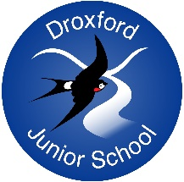
Reading- Information for Parents

Why read?

At Droxford Junior School, we believe that reading is at the centre of a child’s understanding of the school curriculum and an essential life skill. We want children to develop a love of reading, healthy reading habits and for parents to be able to support them beyond just ‘hearing them read.’ Where children enter KS2 and away from book bands some parents may take a step back from reading with their children. However, reading doesn’t just stop once children can read the physical words, having a comprehensive understanding of what is being read, being able to infer, predict and summarise are also key skills.

Reading enjoyment has been reported as more important for children’s educational success than their family’s socio-economic status (OECD, 2002).

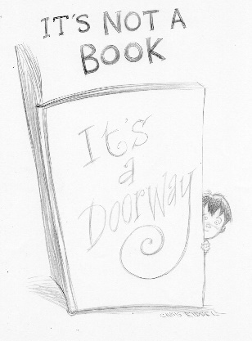
Children need to be able to read with understanding as they progress through school in order to access the curriculum. This becomes increasingly important as they move through their educational journey.

At Droxford, we have a broad and balanced reading curriculum. English lessons are driven by one key text with other genres and text types interwoven into the unit (allowing children to have access to poetry, picture books, and a range of non fiction genres.) There is also reading which is essential to understanding in all of the subjects (even Maths!)

There are many things you can do to support your children at home.

How can I get my child to read?

- Find out what makes them ‘tick’ as a reader. Do they love to find out about the world via news stories or non fiction books? Do they prefer short stories or longer novels? Are they interested in poetry or jokes? Visit a library and choose a book together.
- Be a good role model. Share what you are reading with your child. If it’s a novel, tell them about an interesting character or what you like about the book. If it is an article you read or something you have read for work, share the importance of these.
- Build reading into a daily routine. This may be before bed, in the car on the way to a club or whilst they eat their cereal.
- Create a special ‘reading’ space at home. This may be a beanbag on the landing or a special cushion on the sofa.
- Get your child to read to someone or something. A pet, teddy, sibling or grandparent can make a great reading buddy.
- Complete their reading diaries. Ensure you are aware of your child’s weekly reading and ensure you are signing their reading diaries. Knowing that their teacher’s will be looking at the reading diaries can help them to encourage to read at home.

What should my child be reading?

- Read a range. Try to encourage a range of genres, authors and text types. The bigger the breadth, the better. Magazines, news articles, web pages, recipes, letters, poems are all good!
- See attached a list of books from Hampshire Library Service to help with age appropriate books- a great idea for Christmas presents.
- Speak to other children and parents about books they have enjoyed reading.
- Some children will be reading banded books set by their teachers. These may be ones they bring home or ones they keep in school.

How can I get books for my child?
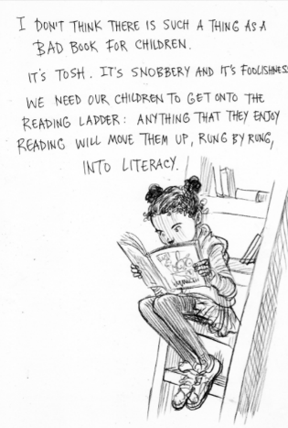
- Your child has access to books in school either in their class reading corner or school library. We have a dedicated librarian (Mrs Daniels) who can help your child select a book. If you would specifically like your child to have help selecting a book with her, just write in your child’s reading diary.
- Hampshire libraries. Visit a local library and spend time browsing the books. You can reserve books too and they will be delivered to the library when available.
- Free Ebooks. Droxford has signed up to Hampshire School Library Service so you can access hundreds of free books online. This will be set up for Year 3 children shortly and a reminder will be sent out for all pupils.

Should my child read independently?

- Yes but not all of the time. Reading independently is an important skill but it is equally important for you to read with your child: read a sentence, paragraph or page each. Alternatively, you can read the speech and your child the narration or vice versa or try dividing up the characters.

What kind of questions can I ask my child when we are reading together?
- Children use VIPERS reading skills (Vocabulary, Inference, Prediction, Explanation, Retrieval, Summarise) advancing to slightly more detailed skills in Years 5/6. Attached are some question stems for you to ask when hearing your child read.

We appreciate this is a lot of information but, given the indisputable importance of reading to any child’s learning and life chances, we are incredibly keen that your children are supported as much as possible.

Look out for our English workshop later in the year.

Happy Reading!

