
Droxford Junior School’s
Year 5 and 6 Reading Skills

Human Dictionary  Explain Word Meaning- read around the word to figure out what it means.  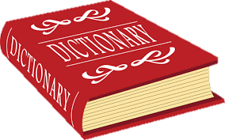 | Fetch!  Retrieval- Look back at the text to find the exact answer using skimming and scanning technqiues.   | Summery Summary    Summarise- Briefly retell the main ideas, points, message or theme of a paragraph or whole text. | Figure it out…  Infer- Use clue and evidence from the text, as well as your own knowledge of the world, to figure something out.  
Crystal Ball    Predict- Use evidence from the text to decide what might happen next. | Put it all together…    Text as a Whole- Explain why characters did certain things, find the main theme of the story or identify the target audience. | Psychiatrist    The Effect of Words- Explain the effect different words have on the reader. | Links  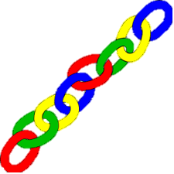  Compare and Contrast- Make comparisons across and between texts. Identifying what is similar or different.

