

Autumn 1 2025 Newsletter

Dear Parents

Welcome back to a new academic year at Droxford Junior School. We would like to offer a special welcome to all the families who are new to our school community. We were delighted to host all the new Year 3 parents last week, for a brief meeting with myself and then to work with children in class and to have lunch altogether.

Strong partnerships are essential; we have an ‘open door’ policy so that issues are resolved quickly and the children are settled, happy and successful. We always encourage children to speak to adults in school so we can help immediately. Please contact the school office if you have any queries or wish to contact your child’s teacher.

Our ‘Skills for Learning’ and School Values are integral to our learning and positive behaviours in school. I am sure, if you are not aware of them already, that you will be during this term – either through your child’s work and successes or subsequent visits to the school which include…

Parents Evening Meetings
Wednesday 22nd October (Roving Bookshop in school) with the author SF Said
Thursday 23rd October
Information on these meetings will be sent via the office in the near future.
Author visit: SF Said

I am delighted to announce that the world-famous author, SF Said will be visiting us on Wednesday 22nd October. Your child may remember – ‘Varjak Paw’ or even it’s sequel, ‘The Outlaw Varjak Paw’?! Since those books, he has written two more – with ‘Tyger’ receiving awards and praise far and wide! SF will be leading two workshops for all children and they can meet him, ask questions and maybe even purchase a signed copy of one his books! I personally believe the Varjak Paw books are incredibly well written and very exciting with stunning illustrations! It will be a fantastic, inspirational day!

SAVE THE DATE: Dig Day – Saturday October 18th (Join us anytime between 9 – 3)
As you know we have been developing the grounds for wildlife, learning and play. This dig day we are planning to plant more plants including spring bulbs and to maintain the wildlife areas. We also wish to plant a living hedge; establish a wildlife area outside my office window (which the children have designed) and repair and make new bug hotels. We have some painting and general maintenance jobs to undertake as well.

If you are able to join us (and you will be fed and watered for your troubles) please let me know via the school office.
adminoffice@droxford.hants.sch.uk

PE and School Sports.
Eagle eyed readers may have noticed a new logo on our school paper work (footer). We are delighted to announce that Droxford Junior School has achieved the School Games Platinum Mark Award for the 2024/25 academic year.

The School Games Mark is a Government-led award scheme, facilitated by the Youth Sport Trust to acknowledge a school's PE & School Sport provision. The Platinum accolade is awarded for schools that have constantly demonstrated high standards by consistently achieving the Gold award over several years. It is the highest standard achievable in this national scheme, only a handful of schools hold this award.

Platinum status reflects a school's commitment in ensuring the quality of the provision and opportunities within PE, School Sport and Physical Activity. Therefore, creating a positive and engaging experience for all students.

The award is a testament to the hard work of the whole school community and we are incredibly proud of all of our students. As a school we are looking forward to maintaining and building upon what we have achieved so far.

Duncan Banham
PE and Sports Coach

Parking
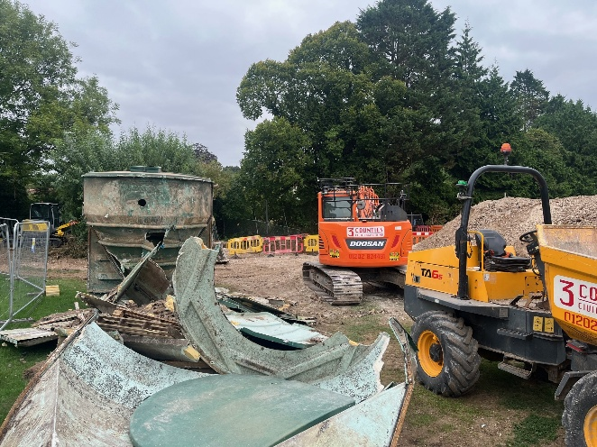
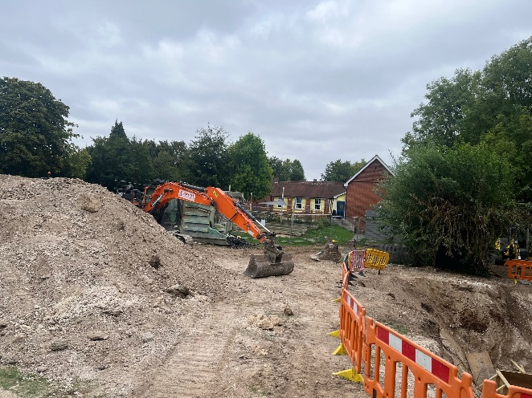
During the summer break and running into the first two weeks of term, the local authority undertook a big building project – replacing the septic tank on the school field.

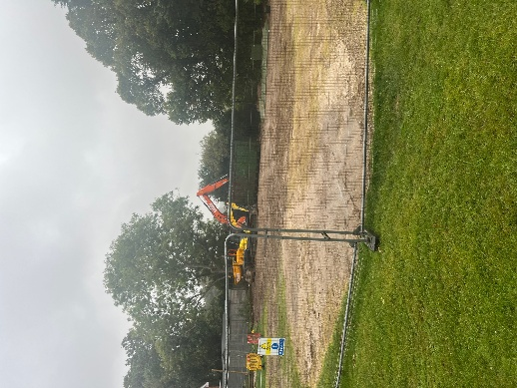
Thankfully completed, we have lost part of the field for a large chunk of the school whilst the grass regrows and we lost our 20-year-old willow dome! The contractors worked hard to ‘make good’ a much-used area but it will take time to heal. The septic tank had to be replaced and there was no choice – the logical time was the summer break.

Unfortunately, the overspill in to this academic year meant we lost our parking area to heavy machinery, vans, lorries and a welfare cabin. With a caravan parked in the parish carpark staff had to park wherever they could, including outside the school, the fire station carpark and the square.

Fortunately, the works are complete and staff are happy with me now!

Like most schools, the school has no parking available for parents and parking for staff is limited. We also have a Montessori nursery next door, where parents drop off very young children. This has added pressures and traffic to the lane which isn’t ideal.

I am so grateful and delighted to see parents are still using the fire station car park and square to park and make the very short and quick walk to school. This is also an ideal time to talk to your children and have a bit of quality time in the fresh air!

We have always advocated for no driving up to school if possible – the lane up to school is so narrow as you are no doubt aware. Obviously not enforceable, it is just an appeal to everyone’s better nature.

FODS

Dear Parents and Carers,
We'd like to invite you to our PTA Annual General Meeting. A flyer with more information is attached.

This is a fantastic opportunity to hear more about FODS, the achievements made over the past year, and learn exactly how the funds you've helped to raise have been used to benefit our children's education and school experiences.
We will also be electing the new committee for the upcoming year and discussing our future plans.
FODS relies on the support of our wonderful parents and every/any bit of involvement really does help.
We would particularly love to welcome new parents to the meeting and to hear new ideas.
Your input is crucial for us to continue providing the best possible support for our school community.
We look forward to seeing you there!
Kind regards, Droxford FODS committee

Open Morning
The school will be showcasing itself in the form of an Open Morning for new Year 3 starters in September ’26.

I will give a short presentation before FODS, the Governors and finally a wonderful tour and presentation led by the children themselves. This is a great opportunity for parents to see the school before making applications to join us.

Please share with anyone you think may be interested. We are expecting lower numbers from the two Infant Schools so are hoping other children from further afield will join us.

That is all for now. Many thank you to all for the great start to the new school year.

Best wishes

Matthew Dampier
Headteacher

Vision: ‘Equipping our children with the knowledge and skills to navigate life successfully’

