Droxford Junior School
Calculation Policy



A guide to mental, written calculations and other strategies used in our school.



Contents:
Page 3 – Aims
Page 4 – Our Key Questions
Page 5 – Maths in Year 3 and 4
Page 6 – Maths in Year 5 and 6
Page 7 – Progressive list of written strategies with examples:
Page 8 – Addition (Year 3)
Page 10 – Addition (Year 4)
Page 11 – Addition (Year 5)
Page 12 – Addition (Year 6)
Page 13 – Subtraction (Year 3)
Page 16 – Subtraction (Year 4)
Page 16 – Subtraction (Year 5)
Page 17 – Subtraction (Year 6)
Page 18 – Multiplication (Year 3)
Page 22 – Multiplication (Year 4)
Page 23 – Multiplication (Year 5)
Page 24 – Multiplication (Year 6)
Page 25 – Division (Year 3)
Page 26 – Division (Year 4)
Page 28 – Division (Year 5)
Page 29 – Division (Year 6)

Page 32 – Further Links

Aims:
This policy aims to ensure consistency in the mathematical written methods and approaches to calculation across years 3-6.
The document is organised according to age related expectation, it is not intended for children to access methods and techniques designed for a different age group.
As part of a child’s learning in calculation, they need to be taught how to select the best method according to the numbers. The hierarchy of thinking should be:

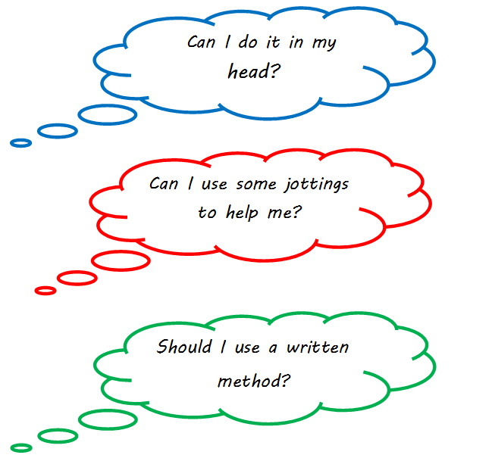

Our Key Questions:
As with all subjects, deep and effective questioning is an important part of teaching and learning.
Maths is not just solving calculations; we also want children to be able to understand the theory behind the written methods and be able to reason deeply about the subject.
In class, we use the following ‘Key Questions’ to stimulate a deeper understand of the subject.

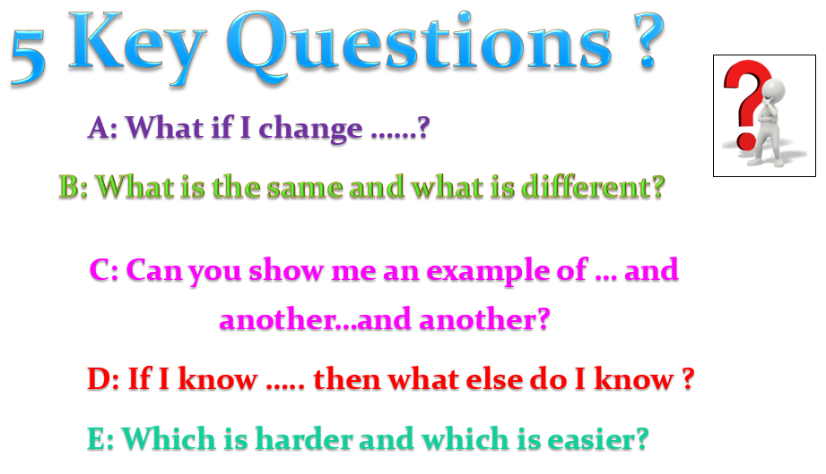

Maths in Years 3 and 4:
In Years 3 and 4, children build on the concrete and conceptual understanding they have gained in the infants to develop a real mathematical understanding. They are taught to use place value and number facts to add and subtract numbers mentally and will develop a range of strategies to enable them to discard the ‘counting in ones’ or fingers-based methods of the infants. In particular, they will learn to add and subtract multiples and near multiples of 10, 100 and 1000, and confidently manipulate numbers in their head. Mental methods for addition and subtraction are vitally important to secure; there will be no rush to move children on to more formal written methods.
Standard written methods for larger numbers are also taught, learned and consolidated; in Years 3 and 4 the methods taught include:
- Column addition (to 3 digit numbers in Year 3. 4 digit numbers in Year 4)
- Column subtraction (to 3 digit numbers in Year 3. 4 digit numbers in Year 4)
- Grid method for multiplication (Year 3: 2 digit by 1 digit numbers. Year 4: Up to 3 digit by 1 digit numbers)
- By the end of Year 4, it is expected that all the multiplication and division facts are thoroughly memorised. From May 2021, Year 4 children will take a ‘Multiplication Tables Check’ national assessment to ensure they have reached the expected standard
- In Year 4, children will also learn efficient written methods for dividing a 2-digit or 3-digit number by a single-digit number by chunking on a numberline
Children will develop their understanding of fractions, learning to reduce a fraction to its simplest form as well as finding non-unit fractions of amounts and quantities. The concept of a decimal number is introduced and children consolidate a firm understanding of one-place decimals, multiplying and dividing whole numbers by 10 and 100.
Children will also measure, compare, add and subtract different measurements, including lengths, money, mass and volume. They will learn to measure and calculate the area and perimeter of simple 2D shapes. Time will also be taught with all children expected to tell time to the nearest minute by the end of Year 4.
In Statistics, children will interpret and present data in a variety of different charts and graphs.
Finally, children will learn the properties of different 2-D and 3-D shapes: investigating angles, symmetry and parallel/perpendicular lines. In Year 4, children will be introduced to plotting co-ordinates on a 2D grid and how to describe movements between positions as translations.

Maths in Years 5 and 6
Children move on from dealing mainly with whole numbers to performing arithmetic operations with both decimals and fractions. They will consolidate their use of written procedures in adding and subtracting whole numbers with up to 7 digits and also decimal numbers with up to two decimal places.

Mental strategies for adding and subtracting increasingly large numbers will also be taught. These will draw upon children’s robust understanding of place value and knowledge of number facts. Efficient and flexible strategies for mental multiplication and division are taught and practised, so that children can perform appropriate calculations even when the numbers are large, such as 40,000 x 6 or 40,000 ÷ 8. Order of Operations (BODMAS), factors and multiples, prime, square and cubed numbers are also taught. Negative numbers are taught in more depth.

In addition, it is in Y5 and Y6 that children extend their knowledge and confidence in using written algorithms for multiplication and division. In Year 5, children will multiply up to 4 digit numbers by a 1 digit number using short multiplication, and up to 4 digit numbers by 2 digit numbers using long multiplication. Year 5 children will also be taught short division for numbers up to 4 digits divided by 1 digit numbers.
These methods are developed in Year 6 by multiplying and dividing numbers with up to 2 decimal places by whole numbers. Long division is also taught for numbers up to 4 digits by 2 digit numbers.
Fractions and decimals will be compared and converted. Fractions and decimals are also added, subtracted, divided and multiplied, and children will calculate simple percentages and ratios.
Children will learn how to read, write and convert between standard units of measurement in more depth. Children will find the area and perimeter, and calculate missing angles, of a variety of shapes. They will also learn to find the volume of cubes and cuboids.
Children will learn to classify geometric shapes by their properties, create 3D shapes using nets and describe position on a full co-ordinate grid.
Children will also begin to learn algebra, simple ratios, scale factors and how to calculate the mean as an average. Finally, children will interpret a wider variety of charts, graphs and tables.

Progressive list of written strategies:
The following pages contain explanations, examples, tips and hints for the written methods recommended to be taught in each year group. Again, it is not recommended for children to move beyond the methods taught in each year group although going back to consolidate understanding of previous methods may sometimes prove advantageous.

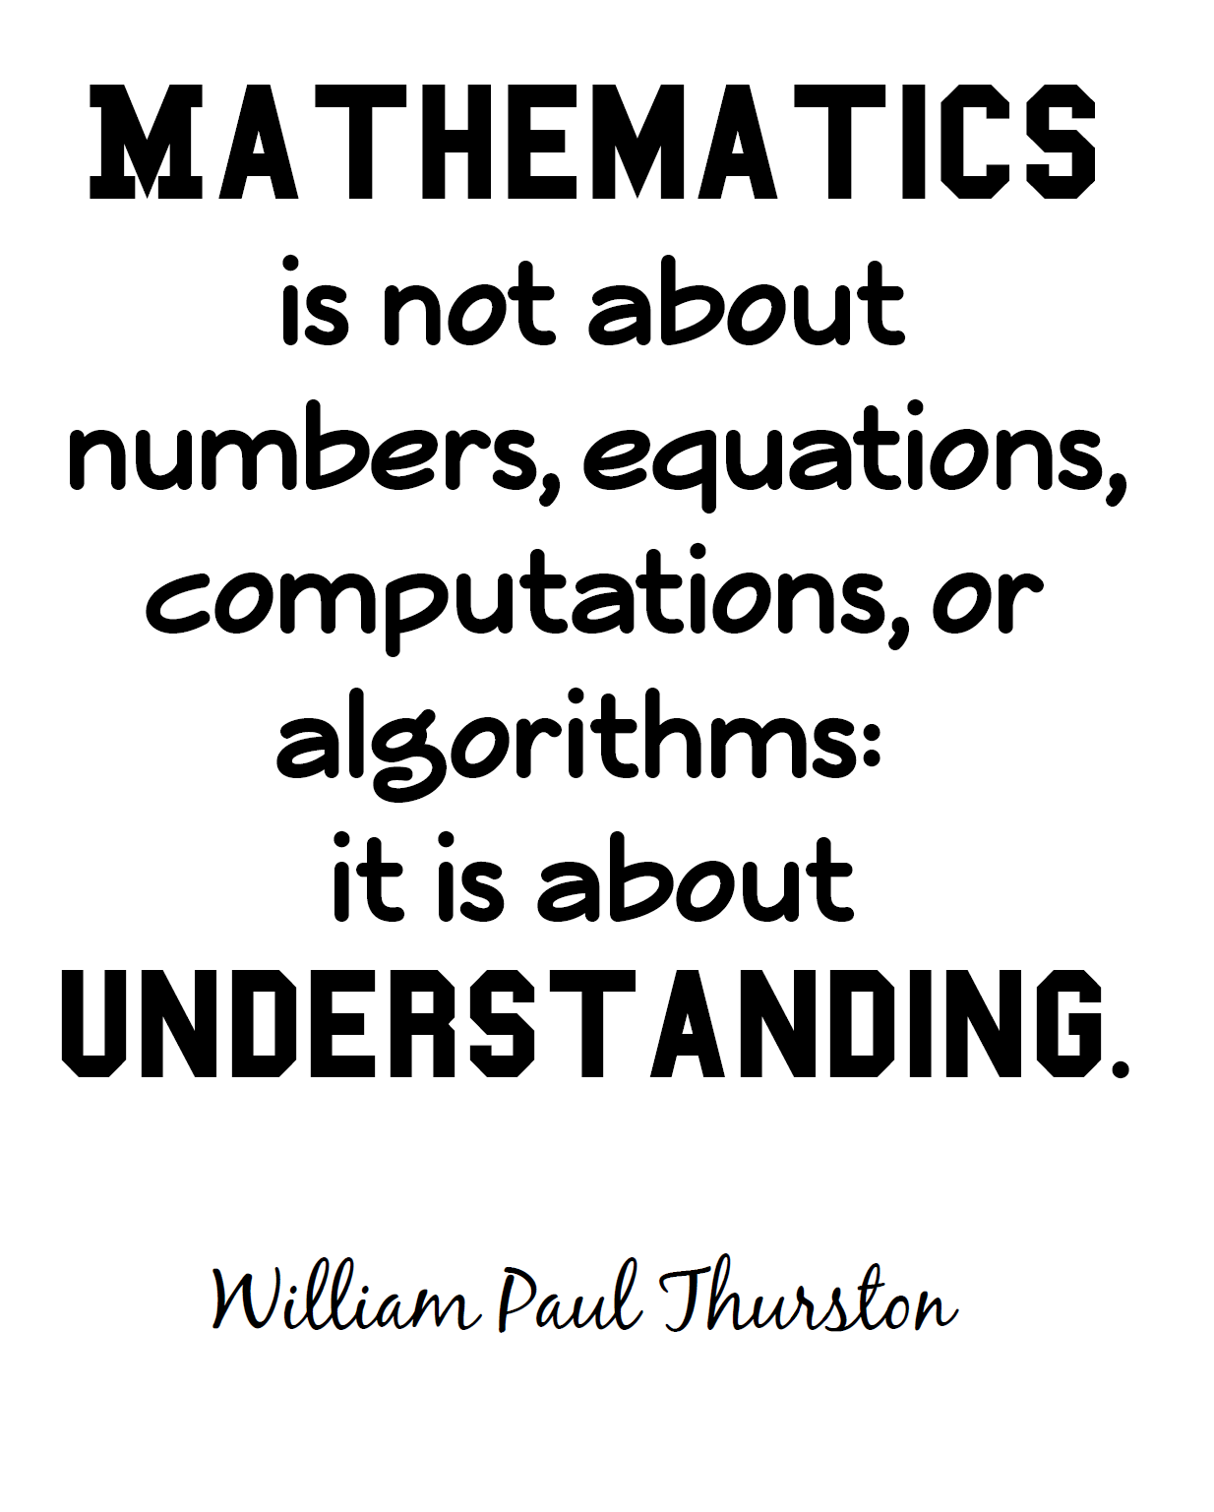



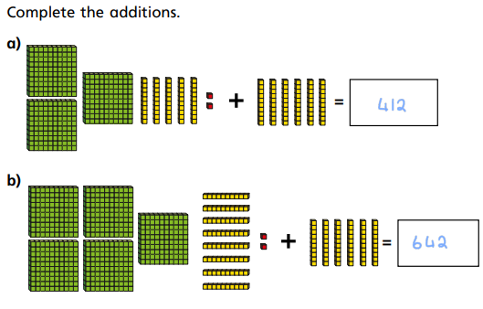
Key vocabulary: add, more, plus, and, make, altogether, total, equal to, equals, double, most, count on, number line, sum, tens, units, partition, addition, column, tens boundary, hundreds boundary, increase, vertical, ‘carry’, expanded, compact, thousands, hundreds, digits, inverse, decimal places, decimal point, tenths, hundredths, thousandths.
328 + 36 = 364
Here, 328 has been made using ‘block 10’ and represented on a HTU grid. Figure 1 then shows 36 (or 3 ‘tens’ and 6 ‘ones’) added on in the row below.
To find the answer, count up the hundreds, tens and ones altogether.
Note that in this example, there are more than 10 ‘ones’ and as such another ‘ten’ has been carried to the middle column.

Children should be confident counting on in 100s, 10s and 1s such as in the example opposite.
This is a key skill in which children should be fully confident before moving on.

Year 3
- Counting in multiples of 1s, 10s and 100s
Counting in multiples of 1s, 10s and 100s is a logical progression from the learning children will have completed during their Number and Place Value unit.

A Hundreds, Tens and Ones (or Hundreds, Tens and Units/HTU) grid is a fantastic resource to support with moving on to learning about the addition of larger and more complex numbers.

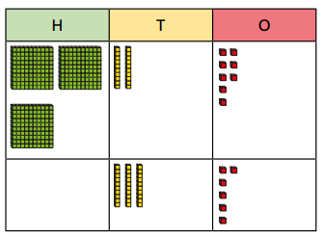

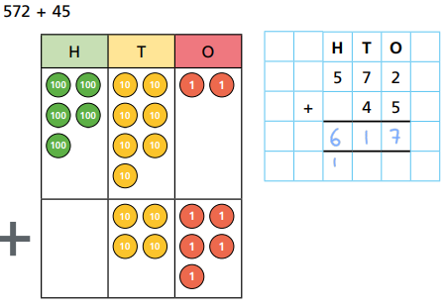
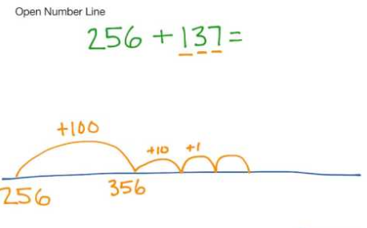
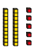
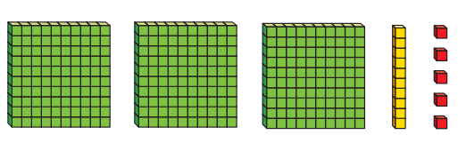
Later on in Year 3, children will be introduced to a traditional Column Addition method.
This can be supported by using HTU grids and place value counters.
Take care to notice when to ‘carry across’ to the next column.
Please note: although these methods will be taught in Year 3, they will be revisited in every year group so children can become fluent with mental arithmetic.
These addition problems can also be represented on a numberline as shown in figure 3 opposite.
Again, the jumps are made in multiples of 100, 10 and 1.
The solution here has been found by counting up the total of ‘hundreds’, ‘tens’ and ‘ones’.
Again, 10 ‘ones’ have been carried over to make an additional ‘ten’.
These questions can also be represented by ‘block 10’ without the HTU grid.

+

325 + 25 = 340

2) Moving towards a formal written method – Column Addition

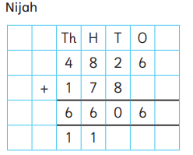
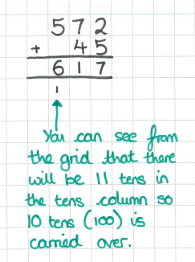
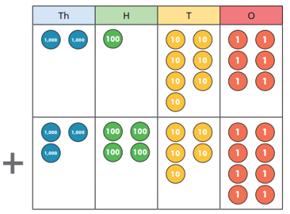
Children will continue to improve their understanding of Column Addition.
Again, place value counters and HTU grids can be used to support learning.
“Explain what mistake Nijah has made”

These types of questions are excellent for checking a child’s understanding of what they have been taught.
Year 4
- Column Addition: 4 digit + 4 digit

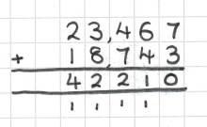
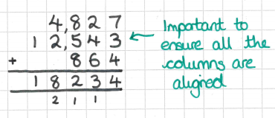
Children will also begin to use column addition to add together amounts of money. This will follow on from learning about decimals and the ‘tenths’, ‘hundredths’ and ‘thousandths’ place value columns. Using money to introduce numbers including decimals is useful as children see the prices of different items written when shopping!
Year 5
- Column Addition: Larger Numbers (up to 5 digits) and decimals, including money.

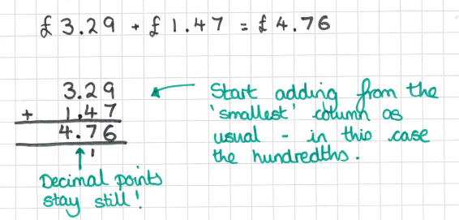
Year 5 children will begin adding larger numbers. They may also add more than 2 numbers together at once using the same column method as previously taught.
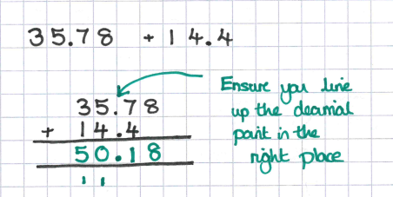
Year 6 children will also continue to find the sum of numbers involving decimals.
By Year 6, children will be confident in using the column method. They will begin to add numbers up to 10 million.

Year 6
- Column Addition: Larger Numbers (up to 7 digits) and decimals.

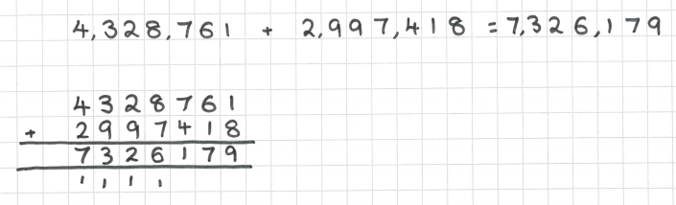

This QR code will take you to a video with a teacher modelling some of the methods detailed above!3

SUBTRACTION

Key vocabulary equal to, take, take-away, less, minus, subtract, leaves, distance between, how many more, how many fewer/less than, most, least count back, how many left, how much less is…, difference, count on, strategy, partition, tens units, take and make, exchange, digit, value, hundreds, inverse, tenths, hundredths, decimal point, decimal.
Year 3
- Counting back in multiples of 1s, 10s and 100s
Similar to addition, Year 3 children will begin to subtract numbers (up to 3 digit – 3 digit) using concrete resources such as ‘Block 10’ and place value counters.
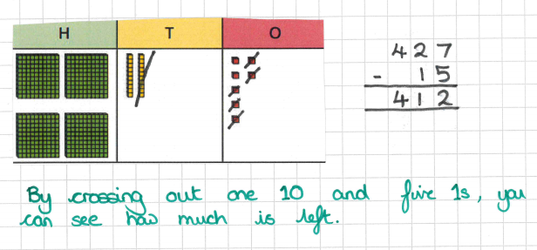

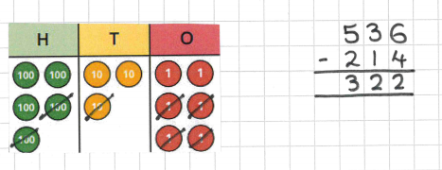

Representing subtraction on a numberline is another important tool.

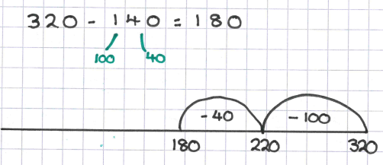

In this example, 140 has been partitioned into 1 hundred and 4 tens. Each ‘jump back’ is then made mentally and recorded on the numberline.
Another example can be seen here:

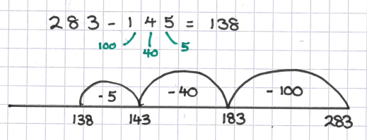

This method of subtraction again relies heavily on children’s excellent understanding of place value and counting in 1s, 10s and 100s.
These are both examples of an ‘unstructured numberline’ as there are no regular intervals or numbers already written underneath the numberline.

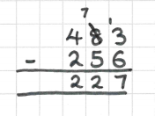
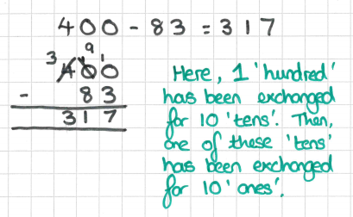
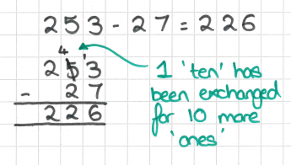
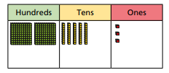
Year 3 children will learn to subtract numbers up to 3 digits from 3 digit numbers.
Important note: sometimes you may have to exchange and borrow from more than one column.
2) Moving towards a formal written method – Column Subtraction

In this example, 7 is bigger than 3; 3 - 7 will give a negative number as an answer.
If we exchange 1 ‘ten’ for 10 more ‘ones’, then we can do 13 – 7 = 6.
This exchanging can be represented practically using ‘Block 10’ or place value counters.
Again, children will be taught the more formal method of column subtraction later on in Year 3.
HTU grids can be used to support this process so that children understand why they may sometimes need to ‘borrow’ from another column. This is also sometimes called ‘exchanging’.

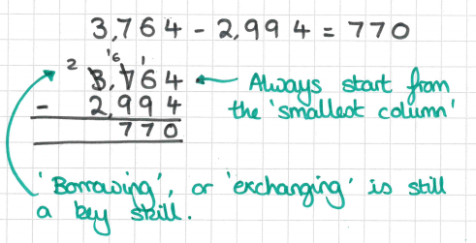
Year 5
- Column Subtraction (up to 5-digit – 5-digit numbers)
Column subtraction will continue to be practised in Year 5 for larger numbers.

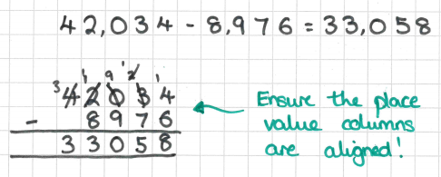

Year 4
- Column Subtraction (up to 4-digit – 4-digit numbers)
Year 4 children will continue to develop their understanding of column subtraction. ‘HTU’ grids can be used to support when needed.

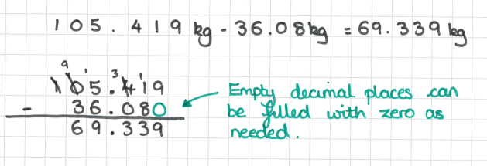
Year 6
- Column Subtraction (with numbers up to 10 million, and numbers including decimals)
In Year 6, children will work with increasingly large numbers. Calculations involving decimals can be solved in many different contexts, for example, mass and volume.

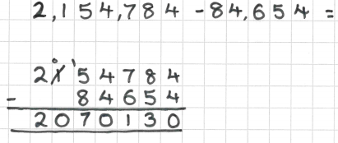

This QR code will take you to a video with a teacher modelling some of the methods detailed above!


MULTIPLICATION

Key vocabulary groups of, lots of, times, array, altogether, multiply, count, multiplied by, repeated addition, column, row, sets of, equal groups, times as big as, once, twice, three times…, partition, grid method, multiple, product, tens, units, value, inverse, square, factor, integer, decimal, short/long multiplication, ‘carry’, tenths, hundredths.
Year 3
- Becoming fluent with times tables
Rapid recall of times tables is key in so many areas of maths. See the diagram below:
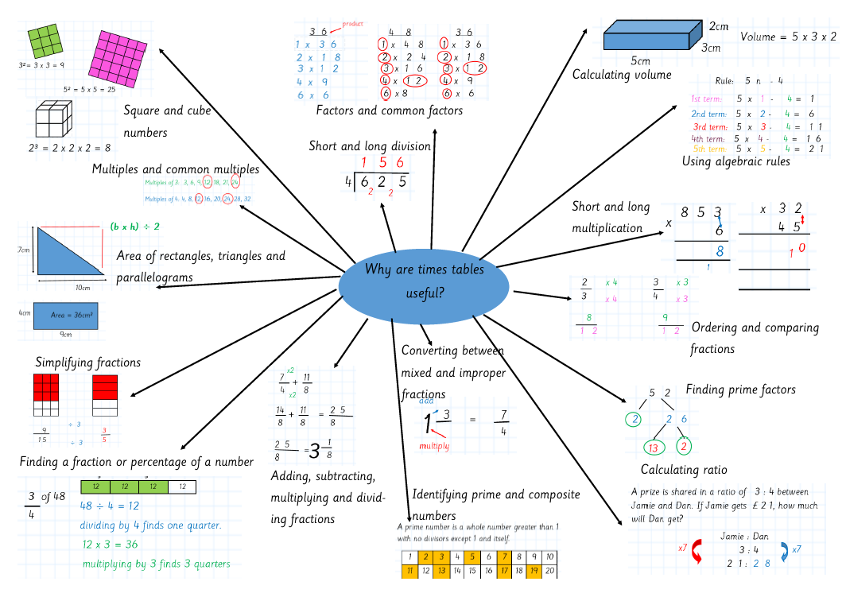

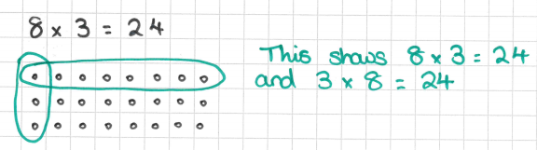
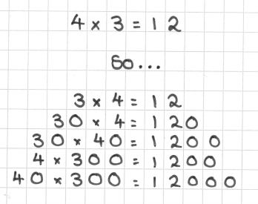
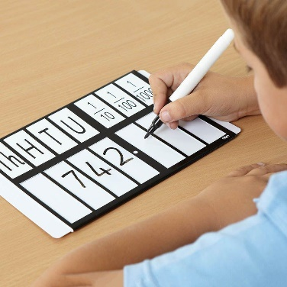
To ensure children are learning their times table facts, the government have introduced a new national assessment. From the 2019-20 academic year, all year 4 children will be expected to complete an online, national times table test. This is in line with the expectation in the national curriculum that all children should be able to rapidly recall times tables facts to 12 x 12, along with the associated division facts.
In the trials carried out in 2018, children had 7 seconds to answer each question and type it into the computer – very rapid recall indeed!
To start in year 3, children will be taught their times tables and how to use that knowledge to derive related number facts, eg.

Children will begin to record multiplication calculations using arrays.

Please look at our ‘Progression in Times Tables’ document for more detail in the teaching of times tables.
Place Value Sliders are used to support.
Another example of an open array:
By drawing rectangles around the array, you can start to split the calculation into parts.
For instance, in the middle diagram, the array has been organised into 3 x 10 and 3 x 2.
You can then draw an open array showing this, without having to draw 36 circles!
This then uses times table facts to solve the problem.
2) Open Arrays
Later in Year 3, children will start to multiply larger numbers using open arrays. This is a good ‘bridge’ towards using a more formal written method.
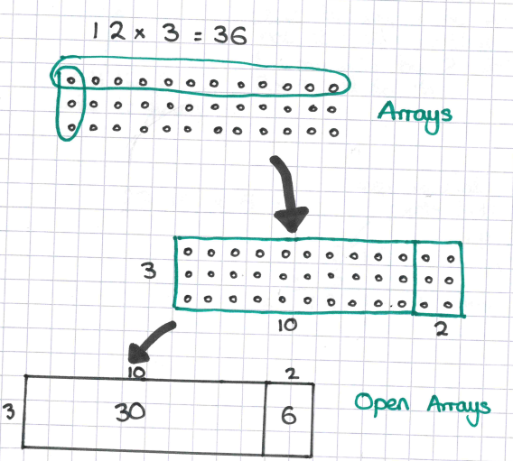

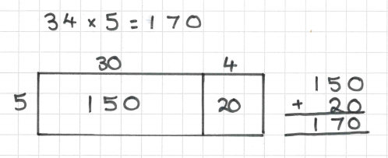
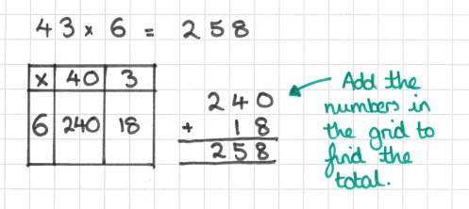
Another example of the grid method for 2-digit x 1-digit number
The grid method is a logical way to complete any multiplication problem.
By partitioning the two-digit number into ‘tens’ and ‘units’, children can use times table facts to solve their calculation.
In Year 3, children will solve 2-digit x 1-digit calculations.
3) Grid Method
Finally, Year 3 children will be taught how to use the grid method. This is one more step on from open arrays.
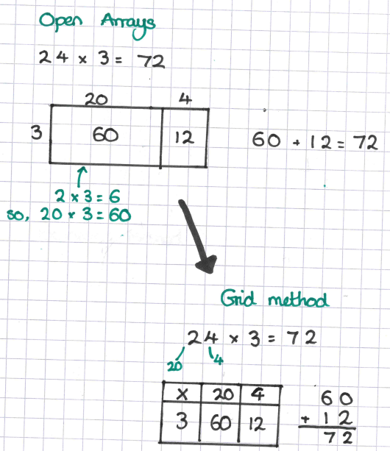

Year 4
- Grid method (up to 3-digit x 1-digit numbers)
Year 4 children will continue to develop their understanding of multiplication through the use of the grid method. They will also continue to practice their rapid times tables recall to prepare them for the Multiplication Tables Check national assessment at the end of the year.

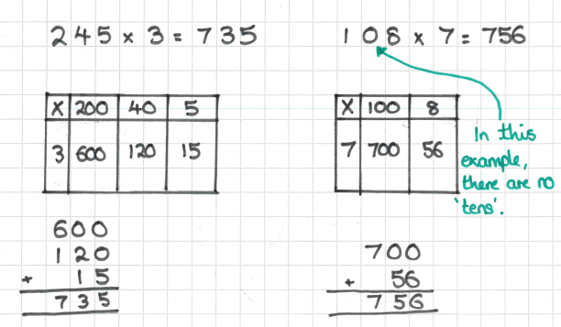

Grid method for 3-digit x 1-digit numbers:

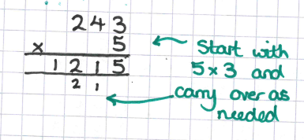
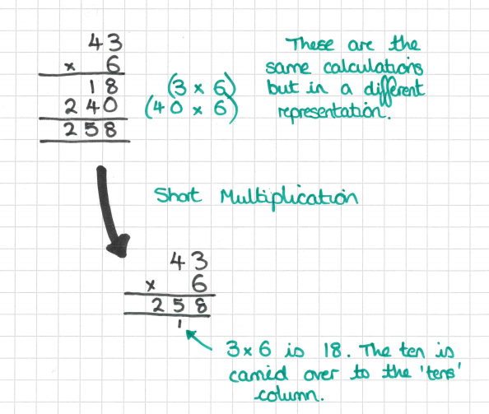
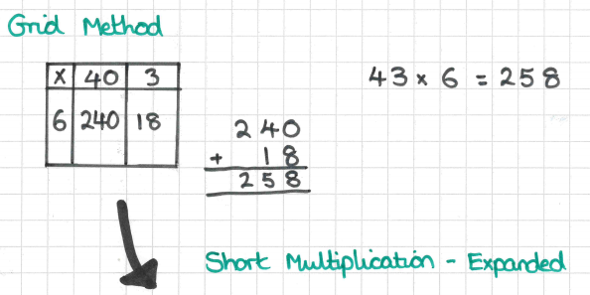
Another example of short multiplication:
Children will begin to use a formal written method in Year 5.
Short multiplication is used when multiplying by a 1-digit number.

In each of these representations of the calculation 43 x 6, the same ‘workings’ are used:
40 x 6 and 3 x 6.

For short multiplication, the digits are carried over to the next place value column when necessary.

Year 5
- Moving towards Short Multiplication

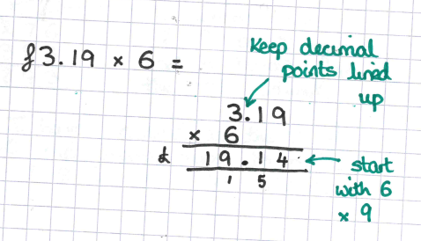
Year 6
- Short Multiplication, including decimals
Children in Year 6 will multiply numbers with decimals by a 1 digit number. Again, money is a fantastic context to use in order to introduce this skill.

- Long Multiplication
Year 5 children will also learn how to use the long multiplication method.
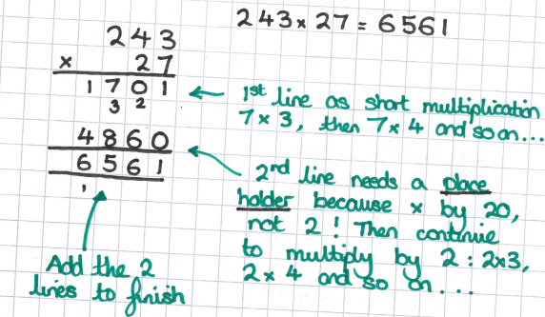

Long multiplication is used to multiply by 2 digit numbers.
In year 5, children will learn to multiply numbers with up to 4-digits by 2-digits.
This will continue in Year 6.


This QR code will take you to a video with a teacher modelling some of the methods detailed above!

DIVISION

Key vocabulary share, share equally, one each, two each…, group, equal groups of, lots of, array, divide, divided by, divided into, division, grouping, number line, left, left over, inverse, short division, ‘carry‘, remainder, multiple, divisible by, factor quotient, prime number, prime factors, composite number (non-prime) common factor
Year 3
- Becoming fluent with times tables
Part of becoming fluent with times tables is learning the associated division facts. See the example, using an array, below:

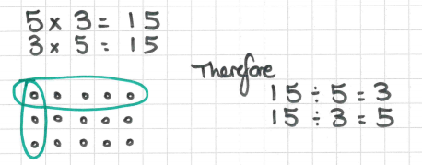

Starting at 0, children will count up to solve division problems.
The next step is learning to start with a jump of ’10 x’
See the example below.
Year 4
- ‘Chunking’ on numberlines
Children will begin to record division calculation using a numberline.
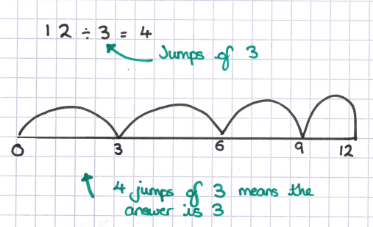

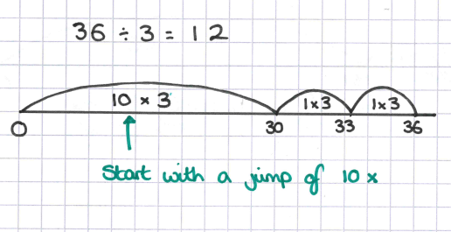

Children will then be encouraged to solve problems in as few jumps as possible. This relies on a strong understanding of times tables. For example:
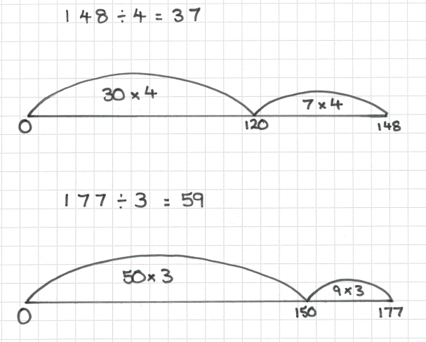
Remainders can also be shown on numberlines.
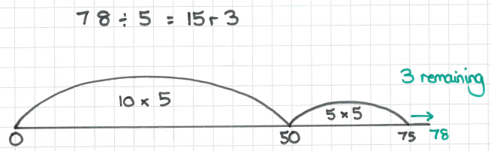
Another example of short division:
Year 5
- Short Division
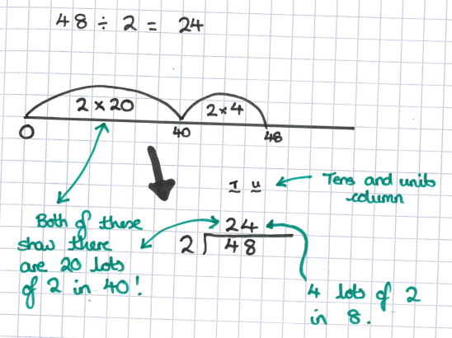
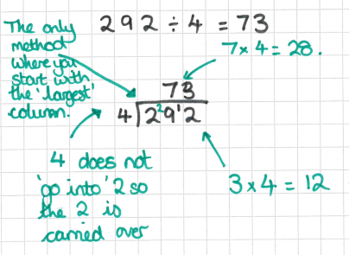

Year 5 children will start to use short division (or the ‘Bus Stop’ method).
This is another method which relies on a rapid recall of times table facts.
In Year 5, children will divide numbers with up to 4 digits by a 1 digit number.
Year 6
- Short Division – with numbers with up to 2 decimal places.
As well as dividing whole numbers which may give decimal answers, children in Year 6 will learn to divide decimals by whole numbers.
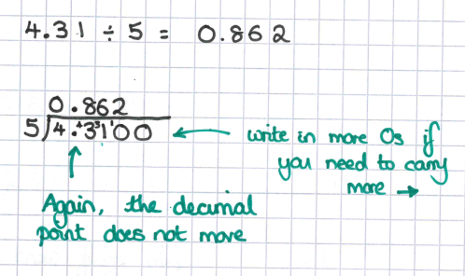

Remainders can also be represented using a short division.
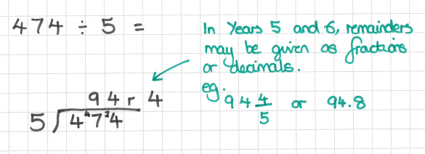

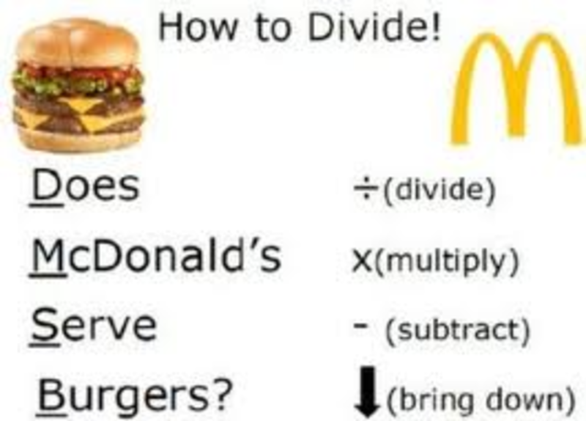
Long division is a simple method, but does involve many steps to complete.
To ensure children do not miss out a step, we use McDonald’s burgers as a reminder!
The phrase ‘Does McDonald’s Serve Burgers’ helps to remind children to:
- Divide
- Multiply
- Subtract
- Bring down
Sometimes this process will have to be repeated more than once.
- Long Division
Finally, in Year 6 children will be taught how to divide numbers up to 4-digits by a 2-digit number. This is long division.

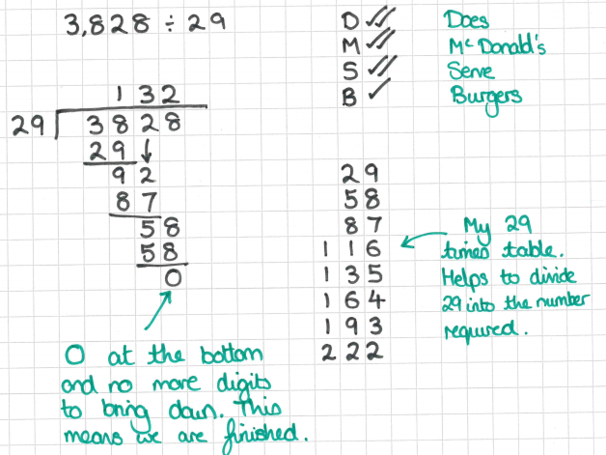
Showing remainders using long division:
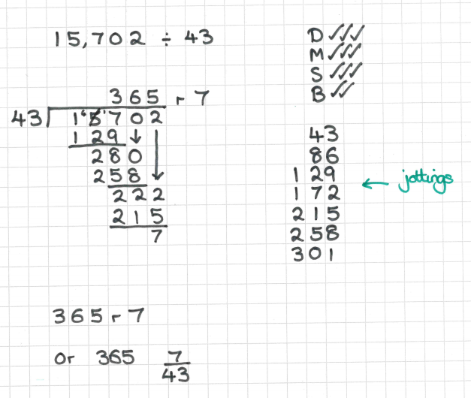



This QR code will take you to a video with a teacher modelling some of the methods detailed above!

See also:

- Maths Knowledge Organisers for each Year group: documents can be downloaded listing the expected knowledge for each Year group from the ‘Maths Support’ tab of the school website –use the QR code opposite!

- Our YouTube channel for ‘How To’ videos. You can find the videos by following the QR codes throughout this booklet.

- ‘Progression in Times Tables’ Document. This can also be found on the ‘Maths Support’ tab of the school website.



