
Develop how we learn outdoors.
Task 59
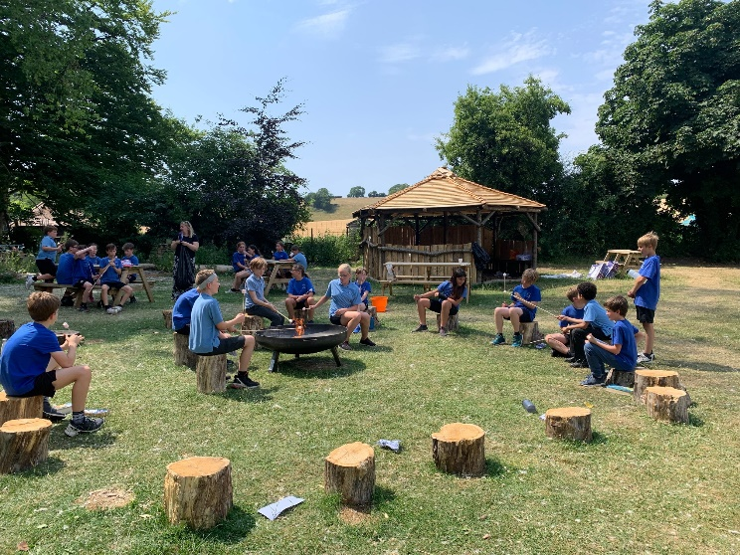
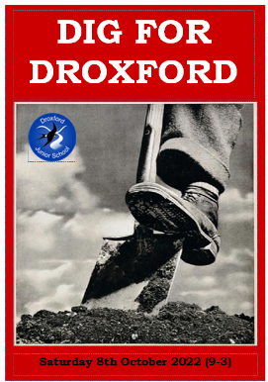
- Take learning outdoors
- Learn from Droxford’s outdoor environments
- Improve the environment for outdoor learning and play
- Have more outdoor activities each week
- Plant more flowers
- Build a gate to our allotment
- Form a new allotment team
- Support Dig Days
- Give the adults in school ideas as to what to teach outdoors
- More play equipment and Den building materials
- Plant fruit trees
- Make the Bug hotels even better!

Vision: ‘Equipping our children with the knowledge and skills to navigate life successfully’.

