
Ensure we are aware of the well-being of all in school
Task 60
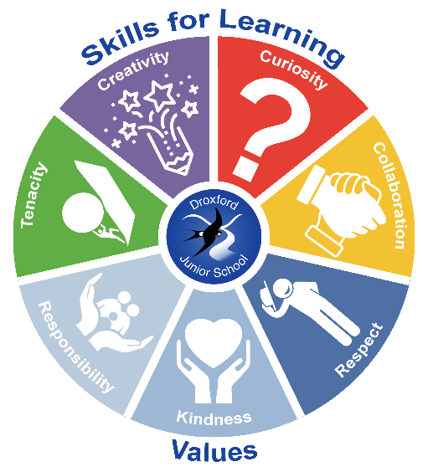

- Raising the profile of well-being through our curriculum (PDL lessons) and Global Connections week
- Ensure children are safe and happy online – have a safer internet day; use Cyber Ambassadors; Harrap Internet safety workshops for all
- Discuss British Values and our School Values
- Play Leaders to help at lunchtimes
- Set up groups led by children
- Develop the role of a new ELSA in school
- Re-establish the Well-being team (Ht, ELSA, Sports Coach, children, TA and Gov) and have at least termly meetings
- Maintain Healthy Schools and Well-being newsletters.
- Link to Outdoor Learning
- Use Luna (school dog) as much as possible
- HT to lead on mental health in school after training (via Leeds Beckett University)
- Embed PDL curriculum; visitors; safe practice and advice to all

Vision: ‘Equipping our children with the knowledge and skills to navigate life successfully’.

