
Be more Eco-Friendly and Sustainable
- Form an eco-committee that work with children, staff and governors to improve school practice
- Go for bronze / Silver awards
- Reduce, Reuse, Recycle more
- Save water and electricity
- Donate used things
- Electric car – Stem Club – The Drox
- Reduce the use of plastics
- Increase the amount we learn in our school curriculum – linked to sustainability
- Compost

Task 58
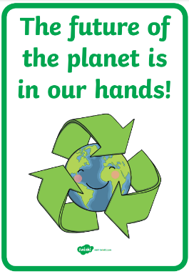
Vision: ‘Equipping our children with the knowledge and skills to navigate life successfully’.

